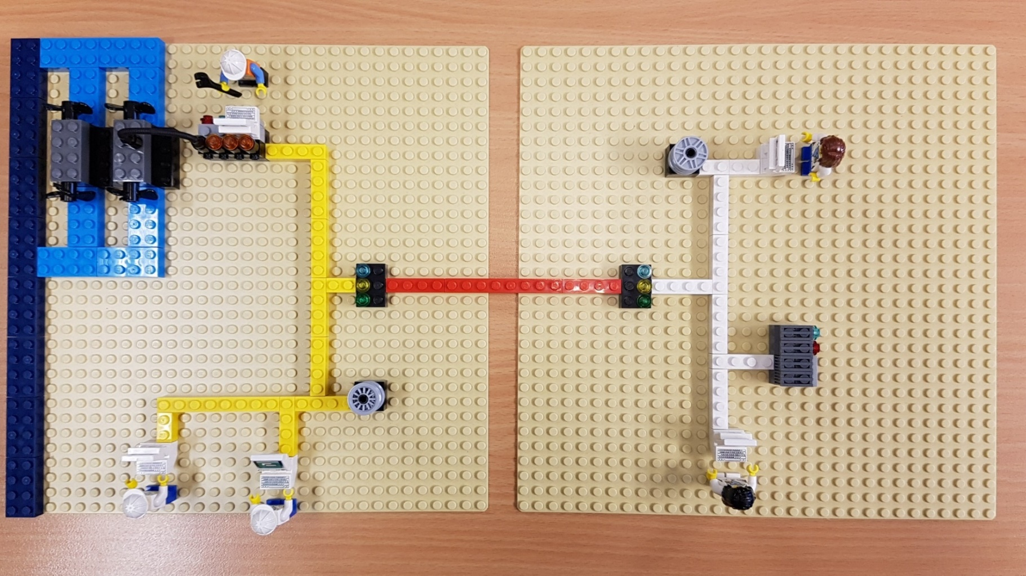

**Router**

**PC**

**PC**

**Turbines**

**Database**

**PC**

**Server**

**PC**

**Database**

**Office**

**Router**

**SCADA Controller**

**Power Plant**

**Decisions & Disruptions**

* Your group represent the board of directors of a power plant.
* The game board above represents a company that has just been added to the business portfolio. It has **zero** security. It is the group’s job to develop the security of this new business over the next 4 years.
* Groups are given £100k per year to invest as they see fit and any money that they don’t spend can be carried over to the following year – They can’t have any more! Players will receive a progress report at the end of each year. At the end of the game there will be a review.
* The cards in front of you are the security features available to buy. Decide as a group what to buy for this year, and then input this into the online game. Put purchased cards to one side/discard.
* Elect one member of your team to be the Game Master, who should follow the QR code on their mobile device to record the groups choices and get feedback.

**Some Information on the Power Plant**

*Scan me to play Decisions and Disruptions!*

* This is a hydroelectric company. The **turbines** generate electricity which is the product of your company.
* The plant network is connected to the **internet** via a **Router.** The plant and office are separated by many miles and connected only through the **internet** (Red bricks). The office network (White bricks) is also connected to the internet via a **Router.**